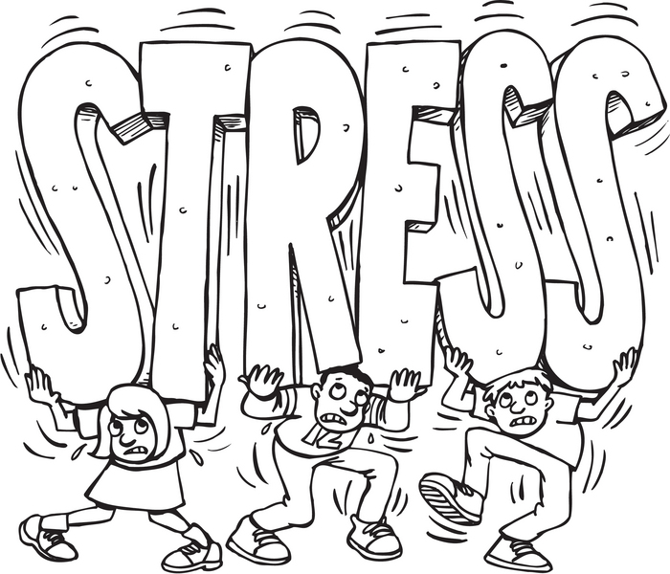

“Stress is anything that causes physical and/or mental wear and tear on the body and mind”

(Joyce V. Fetro, Personal & Social Skills, 2000)

What types of things can create stress in our lives?

**School**

* + Tests, quizzes, projects, assignments, difficult material

**Friends**

* + Dating, fighting, peer pressure, social media, making new friends

**Family**

* + Parents, siblings, finances, divorce, illness, pets, work

**Health**

* + Injury, illness, disabilities, your body is changing

**Extracurricular Activities**

* + Sports, clubs, practices, teams

How do I know if I am stressed? What does stress feel like?

**Stress feels different for everyone, but some common signs of stress include:**

* Tense muscles
* Headache
* Difficulty sleeping/sleeping too much
* Feeling nervous
* Upset stomach
* Forgetfulness
* Racing thoughts

Sometimes life can be very stressful, but the **GOOD NEWS** is that there are many things **YOU** can **DO** to help yourself feel better!

C:\Users\scharvat\AppData\Local\Microsoft\Windows\Temporary Internet Files\Content.IE5\CIL0ODYD\MC900446244[1].wmf**Exercise**

* + Take a walk, run, dance, lift weights, yoga, walk the dog, ride your bike

**Take a break**

* + C:\Users\scharvat\AppData\Local\Microsoft\Windows\Temporary Internet Files\Content.IE5\6TWMQJLJ\MC900446250[1].wmfTake an hour break to clear your mind and rest
  + Watch TV, read, nap, etc.

**Write in a journal**

* + Write about how you are feeling and why?

C:\Users\scharvat\AppData\Local\Microsoft\Windows\Temporary Internet Files\Content.IE5\CIL0ODYD\MC900295297[1].wmf**Organize your calendar**

C:\Users\scharvat\AppData\Local\Microsoft\Windows\Temporary Internet Files\Content.IE5\S4179RK9\MC900446236[1].wmf**Cook or bake**

* + Cooking and baking can relieve stress and make you smile

**Do something to help someone else**

* + C:\Users\scharvat\AppData\Local\Microsoft\Windows\Temporary Internet Files\Content.IE5\S4179RK9\MC900438012[1].wmfHelping others makes us feel good about ourselves

**Clean**

* + Clean your room, backpack, locker, do laundry
* Make a schedule and stick to it!

When you feel stressed, it is important to share your feeling with people who care about you.

C:\Users\scharvat\AppData\Local\Microsoft\Windows\Temporary Internet Files\Content.IE5\CIL0ODYD\MC900434601[1].wmfThere are lots of people in your life who you can turn to:

* Parents
* Counselors
* Siblings
* Teachers
* [](http://www.google.com/url?sa=i&rct=j&q=&esrc=s&frm=1&source=images&cd=&cad=rja&docid=0azypUMdsCPRNM&tbnid=b0PqLZKY_fbrAM:&ved=0CAUQjRw&url=http://gcaggiano.wordpress.com/tag/stick-figure-families/&ei=_7MMU7j_I_OFyQG9yoCoAQ&bvm=bv.61725948,d.aWc&psig=AFQjCNG10N-lS8DT3WY7-QZ9j9Gh4-xX_A&ust=1393427824504904)Coaches
* Grandparents
* Aunts/Uncles
* Friends
* Cousins
* Tutors